Basic Variable Capacitor ES-9079

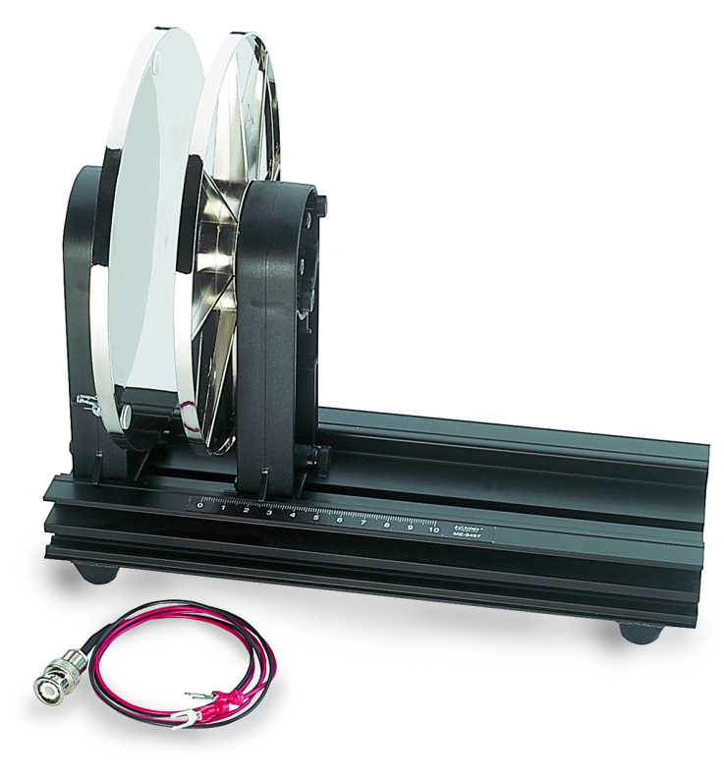

|  |  |
| --- | --- |
| Url | https://www.pasco.com/products/lab-apparatus/electricity-and-magnetism/electrostatics-and-electric-fields/basic-variable-capacitor?srsltid=AfmBOoqA9lhAVwtX6DTCQvyDfofH_C5aVnEIe-OwRxOWA_Uw5GhoZSfW#experiment-panel |
| Video | https://www.youtube.com/watch?v=ogUnayGxttw |

## Product Summary

Two 18 cm diameter plates allow the capacitance to be varied from 225 pF to zero by sliding the movable plate in its 28 cm long track. The sliding plate has adjustment screws to make the plates parallel to each other. Electrical connection studs are located on each plate.  
  
A BNC connector cable is provided for connection to an Electrometer.

### What's Included

* **1x** Basic Variable Capacitor
* **1x** BNC connector cable for connection to an Electrometer